**Mini Project Documentation**

**About website**

Name: Bloom

It is a skin care website/ App where it has survey for you skin condition based on which the ingredients in products will be recommended (example if a user is having dry skin and need hydration based on survey website will recommend hyaluronic acid as ingredient (and also recommends the related products). Along with this is a user is sure of what to buy, then user can directly search for product and buy.  
This app/website will not have any cosmetic products it will only have skin care products.

**Stake holders**

1. **Buyer**
2. **Seller**
3. **Admin**

**Functionality**

|  |  |  |
| --- | --- | --- |
| **Seller** | **Buyer (user)** | **Admin** |
| * Signup/Register (Name, mail ID, Phone number, address, password, payment details) * Profile(About us, Image) * Shop details (name, address, license image, address proof, phone number, Branches) * Type/brands of product sold * Offers * Description of products * Respond to review * Delete account. | * Signup/Register (Name, mail ID, Phone number, address, password, payment details) * Profile (Profile photo, Gender, preference/interests, age) * Subscriptions * Survey taking * Recommendation based on survey. * Buy Product (category wise and search wise) * Sort and filter * Pagination * Cart * Gifting option * Mode of payment * Delivery details * Shipment and billing details * Tracker * Return, replace or refund. * Write review(by images videos and text) * Delete account. | * Store the data * Provide service and resolve issues * Verify the users and sellers * Maintain and track quality and finance |

**Input and action**

1. **Sign up / Login**

|  |  |
| --- | --- |
| **Inputs**  Name  mail ID  Phone number  Password  Confirm password. | **Actions**  Checking username  Verify email id  Verify mobile number(OTP)  Show password  Hide password  Captcha & Not a robot Log In / LogIn with google/FB  Submit |

**Home Page**

|  |  |
| --- | --- |
| **Inputs**  Survey  Category  Profile  search | **Actions**  Display products under category  Save survey and recommend products  Advertise  Display products category wise |

**Wireframes**

**Sign up Page**

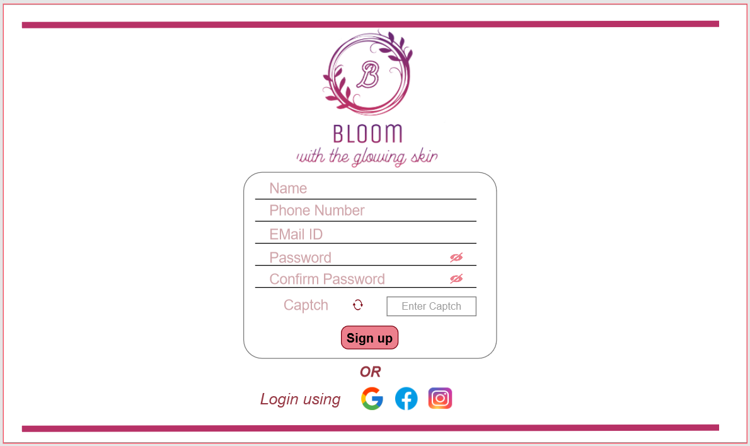

**Log In Page**

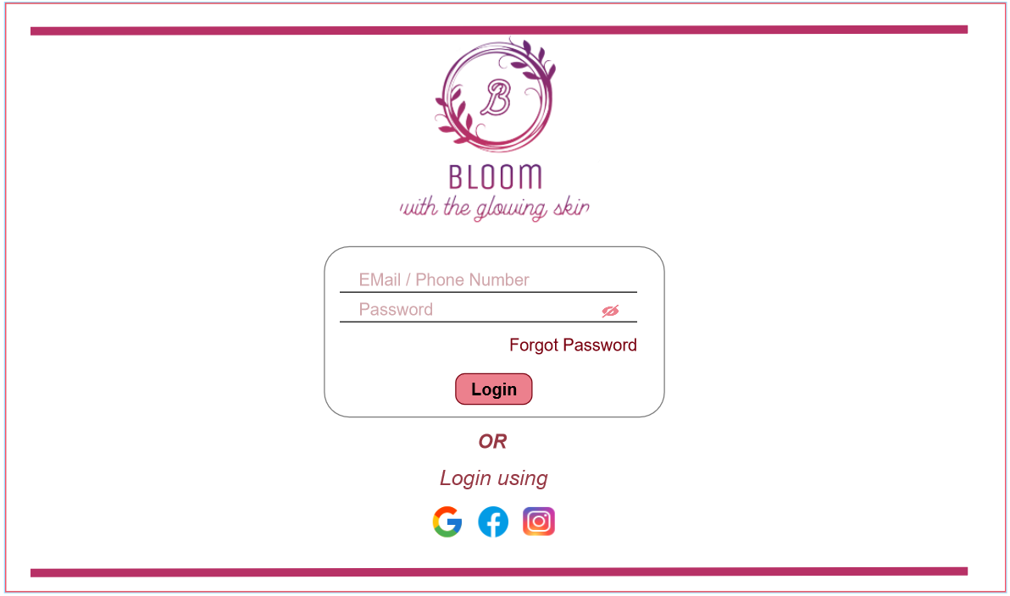

**Verify otp to reset password when clicked on forgot password**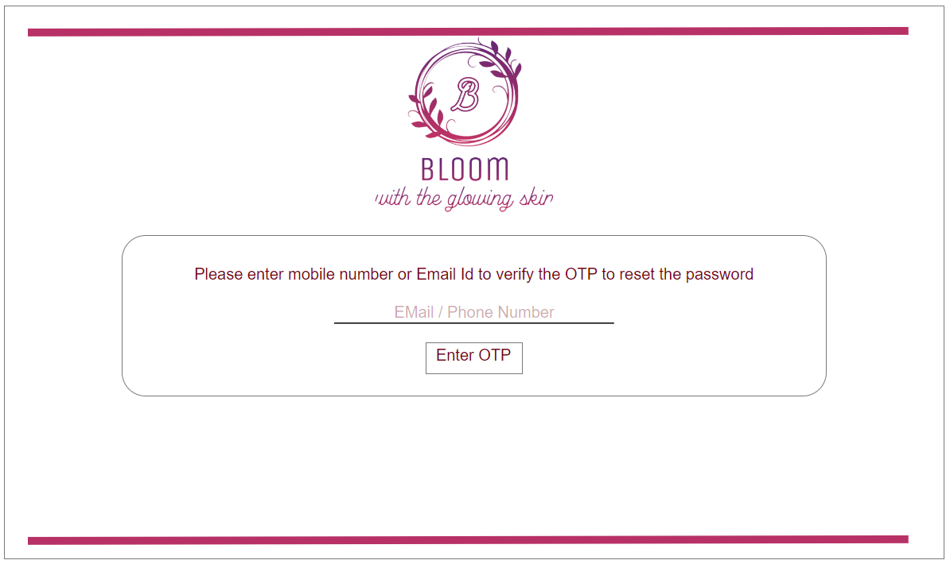

**Password reset page**

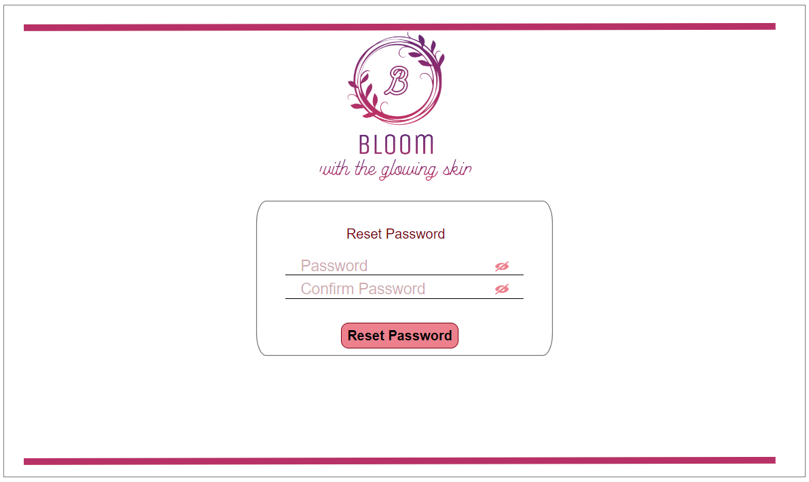

**Password changed successfully**

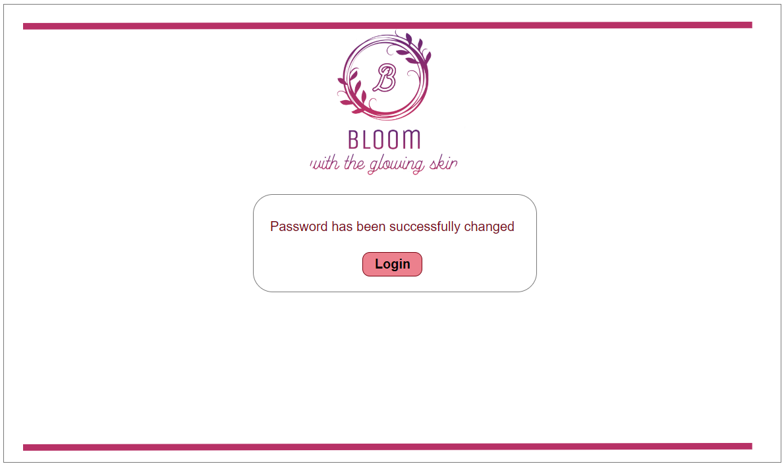

**Home Page**

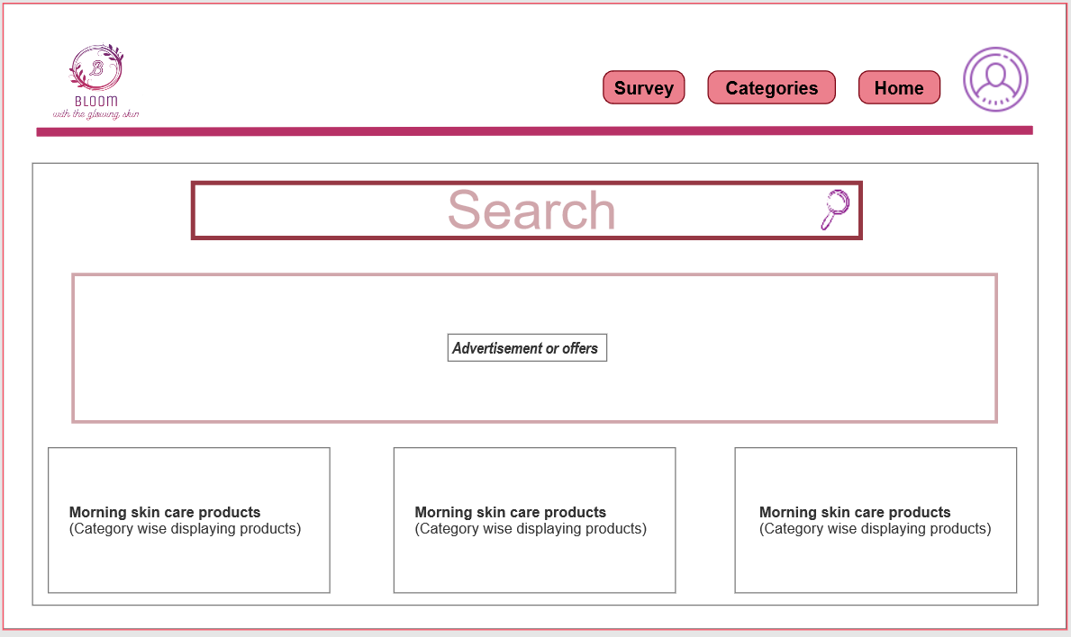

**Survey quiz page(Sample)**

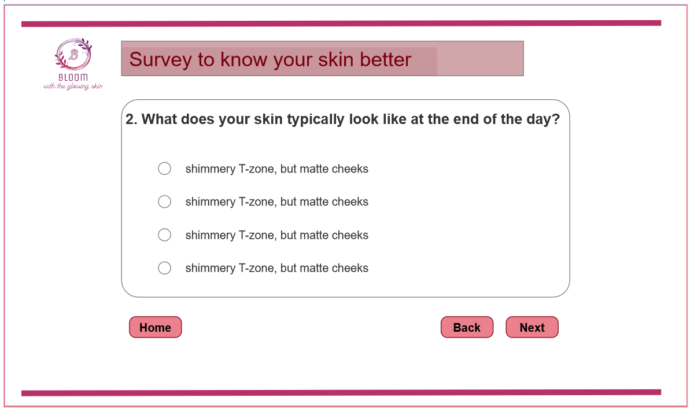

This is a survey sample page, more questions will be there in same format.

**Category wise product display**

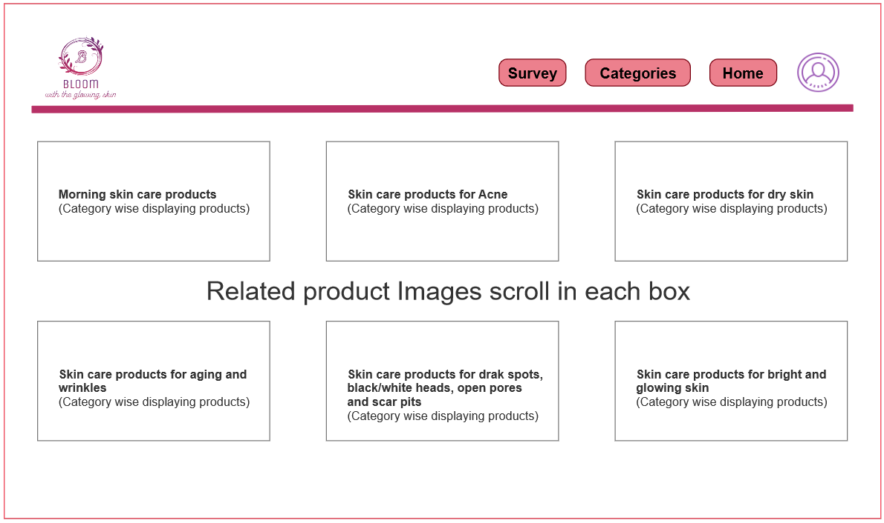

**Database**

Columns and Rows

Tables -> columns

Master Table

**I need help in getting master table in this website**

Sign up / Login

* Name
* mail ID
* Phone number : Primary Key
* Password

Create table registration_details (

    Name varchar(255),  
    MailID varchar(255),  
    PhonnNumber int,  
    Password varchar(255)

);

|  |  |  |  |
| --- | --- | --- | --- |
| Name | MailID | PhoneNumber | password |
| Rashmi | [abcd@gamil.com](mailto:abcd@gamil.com) | 1234567892 | W,kfahb |
| Vinay | [safdjb@gmail.com](mailto:safdjb@gmail.com) | 6546546164 | Ksjefhi |
|  |  |  |  |